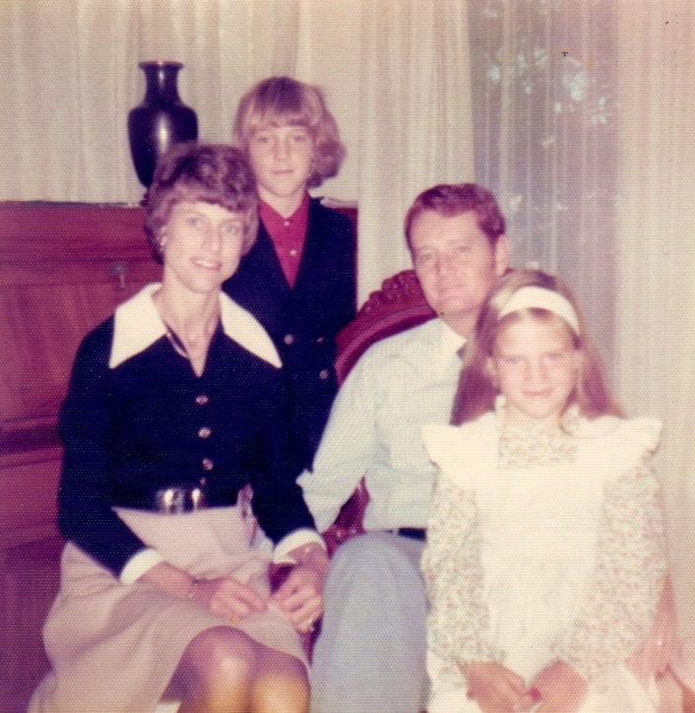

Moore family – 1975



Brian Crenshaw Moore - 1976-77, age 11



Elaine Katherine Moore – 1983